Joyce Spencer Awards - Round 6 Application
The Joyce Spencer Awards are to support regional NSW textile artists or collectives to deliver new artworks or exhibitions. Named after the textile artist Joyce Spencer (1928 – 2019), the awards are made possible with funds from Joyce's family and Western Riverina Arts, in partnership with the Cad Factory.

In 2026:

- One fellowship of $4000 will be awarded to a mid-career artist or group to assist in achieving their outcome;
- A $1500 highly commended award; and
- A $600 prize will also be awarded.

To be eligible, the artist or lead artist must reside in regional NSW. Regional NSW does not include Greater Sydney, the Central Coast, Newcastle, Wollongong or the Blue Mountains.

Round 6 applications will close on Friday 19 June 2026 at midnight. All applicants will be notiﬁed of the results on Friday 10 July 2026. Proposed projects should be delivered between August 2026 and December 2028.

Once you have filled this form, please email to adele@cadfactory.com.au

* Indicates required question

- Email *

Joyce Spencer. Photo: James T Farley

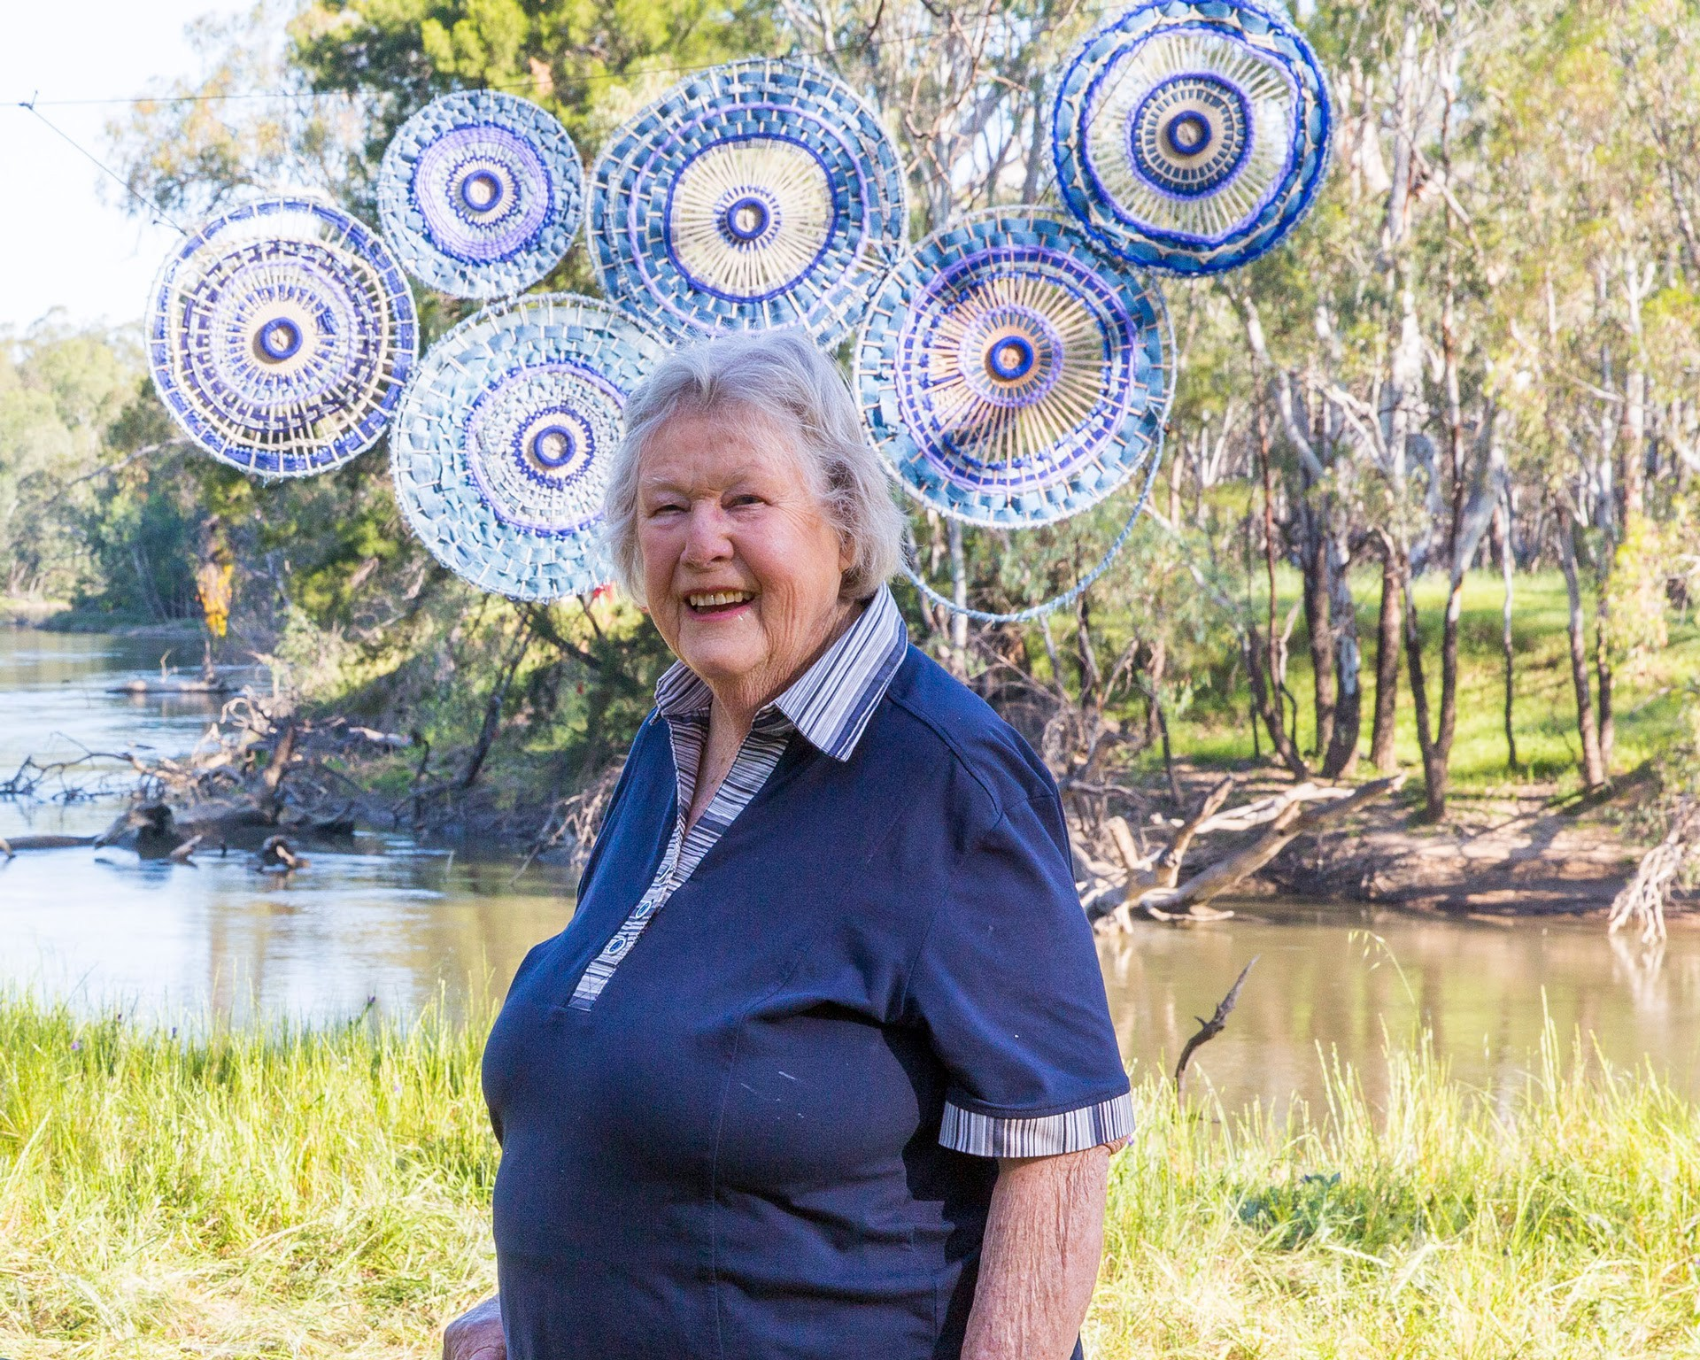

This form is open to artists applying as individuals or on behalf of an arts collective.

If you are applying as a collective please ﬁll out the form with the details of the lead artist/primary contact, with additional information about the rest of your collective where requested.

- Legal name of applicant/lead artist (First and last name required) *

- Preferred name (if diﬀerent to the above)

- Name of arts collective and list of members (if applicable)

Pronouns *

- She/Her
- He/Him
- They/Them
- Other:

Date of birth *

Town/suburb of residence *

State *

 NSW

If other, please note you are NOT eligible for this opportunity

Postcode *

Phone number *

Name of your local Regional Arts Board *

- Please describe your project or exhibition (500 words) *

Please attach a 1 page CV for every artist involved in the project or
exhibition. *
The primary applicant or collective's name must be included in the ﬁle name.
Word doc and PDF ﬁles accepted.

Please attach a conﬁrmation letter from a gallery, local Council, RADO,
arts organisation etc outlining you have a conﬁrmed venue or site-speciﬁc location. *
The primary applicant or collective's name must be included in the ﬁle name.
Word doc, PDF and image ﬁles accepted.

Please attach a single document containing up to 10 images of your
work, including clearly written titles for each work. *
The primary applicant or collective's name must be included in the ﬁle name.
PDF or Powerpoint presentations accepted. (max. 100MB)

Would you like to receive e-newsletters from the Cad Factory and/or Western Riverina Arts?
Check all that apply.
- I would like to sign up to the Cad Factory e-news
- I would like to sign up to Western Riverina Arts e-news
- I already receive these e-newsletters

- Additional Notes (optional)

Thank You
Your application will be assessed by our selection panel. All applicants will be notiﬁed of the results on Friday 10 July 2026.

Please email your filled form and all relevant attachments to adele@cadfactory.com.au

